Kubernetes Task-8

- Create and Test a Kubernetes Pod with an EmptyDir Volume
- Configure a HostPath Volume in Kubernetes and Validate Data Persistence
- Deploy an Amazon EBS Volume Using Persistent Volume and Persistent Volume Claim (PVC)
- Set Up an Amazon EFS Volume and Attach it to Multiple Pods
- Implement and Test Liveness and Readiness Probes in a Kubernetes Pod

Task 1: Create and Test a Kubernetes Pod with an EmptyDir Volume

Objective
To create a Kubernetes Pod with an emptyDir volume, mount the volume into the container, write data to it, and verify that the data can be accessed while the Pod is running.

Implementation Steps

1. Create the Pod YAML
On the Kubernetes master:
nano emptydir-pod.yaml
Add:
apiVersion: v1
kind: Pod
metadata:
name: emptydir-pod
spec:
containers:
- name: nginx
image: nginx
volumeMounts:
- name: shared-storage
mountPath: /data

volumes:
- name: shared-storage
emptyDir: {}
Save and exit.
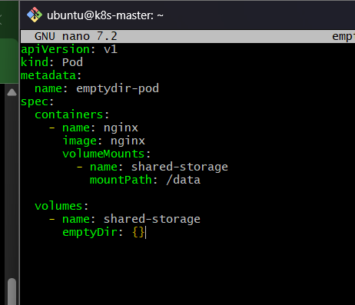

2. Create the Pod
kubectl apply -f emptydir-pod.yaml
Expected:
pod/emptydir-pod created

3. Verify the Pod
kubectl get pod emptydir-pod -o wide
Expected status:
NAME READY STATUS RESTARTS AGE
emptydir-pod 1/1 Running 0 ...
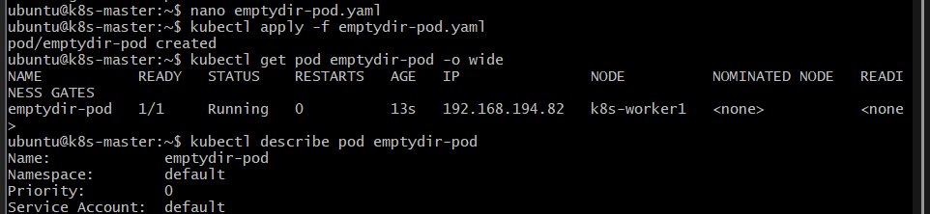

4. Verify the Volume
kubectl describe pod emptydir-pod
Look for:
Volumes:
shared-storage:
Type: EmptyDir
This confirms that Kubernetes created an emptyDir volume.
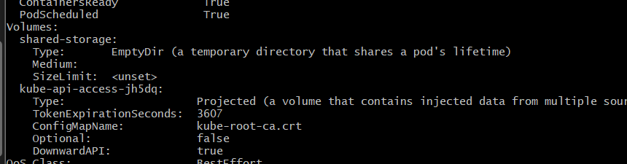

5. Create a File Inside the Volume
Execute a command inside the container:
kubectl exec emptydir-pod -- sh -c 'echo "Hello from EmptyDir" > /data/test.txt'

6. Read the File
kubectl exec emptydir-pod -- cat /data/test.txt
Expected:
Hello from EmptyDir
This proves that the container can write to and read from the emptyDir volume.
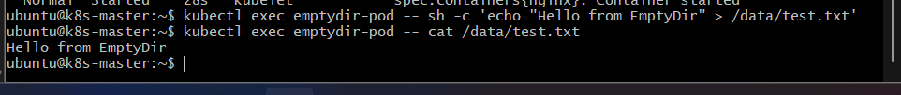

7. Verify the Mount
kubectl exec emptydir-pod -- df -h /data
You can also check:
kubectl exec emptydir-pod -- ls -l /data
Expected:
test.txt
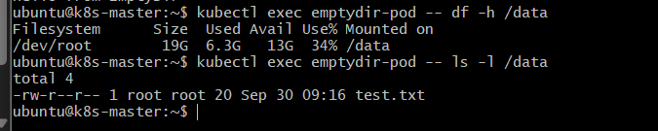

Outcome
- An emptyDir volume was successfully created and mounted at /data.
- Data was successfully written to the volume.
- The data was successfully read from the volume.
- The volume exists only for the lifetime of the Pod.
- If the container restarts, the emptyDir data normally remains available.
- If the Pod itself is deleted and recreated, the emptyDir volume is deleted and its data is lost.

Task 2: Configure a HostPath Volume in Kubernetes and Validate Data Persistence

Objective
To configure a Kubernetes Pod with a HostPath volume, store data on the Kubernetes node's filesystem, delete and recreate the Pod, and verify that the data remains available on the same node.

Implementation Steps

1. Create the HostPath Pod YAML
On the Kubernetes master:
nano hostpath-pod.yaml
Add:
apiVersion: v1
kind: Pod
metadata:
name: hostpath-pod
spec:
nodeSelector:
kubernetes.io/hostname: k8s-worker1

containers:
- name: nginx
image: nginx
volumeMounts:
- name: host-storage
mountPath: /data

volumes:
- name: host-storage
hostPath:
path: /opt/kubernetes-data
type: DirectoryOrCreate
Save and exit.
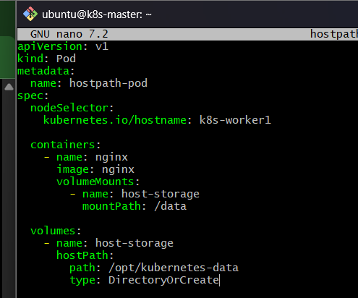
Why nodeSelector is used:
hostPath stores data on the filesystem of a specific Kubernetes node. We therefore pin this Pod to k8s-worker1, so that when we recreate the Pod, it uses the same node and can access the same host directory.

2. Create the Pod
kubectl apply -f hostpath-pod.yaml
Expected:
pod/hostpath-pod created

3. Verify the Pod
kubectl get pod hostpath-pod -o wide
Verify that the Pod is running on:
k8s-worker1
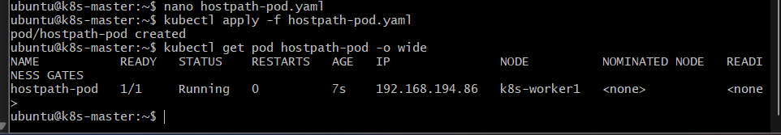

4. Verify the HostPath Volume
kubectl describe pod hostpath-pod
Look for:
Volumes:
host-storage:
Type: HostPath
Path: /opt/kubernetes-data
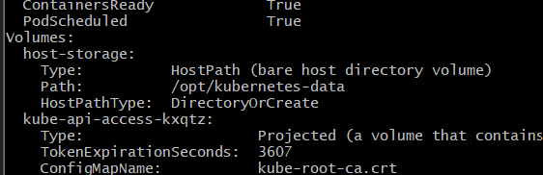

5. Create Data Inside the Volume
Run:
kubectl exec hostpath-pod -- sh -c 'echo "Hello from HostPath" > /data/test.txt'
Verify:
kubectl exec hostpath-pod -- cat /data/test.txt
Expected:
Hello from HostPath
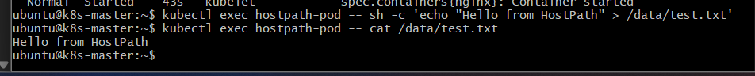

6. Verify the Data Directly on the Worker Node
SSH into k8s-worker1:
ssh ubuntu@<worker1-private-ip>
Then:
sudo ls -l /opt/kubernetes-data
Expected:
test.txt
Read the file:
sudo cat /opt/kubernetes-data/test.txt
Expected:
Hello from HostPath
This confirms that the data is actually stored on the worker node's filesystem.
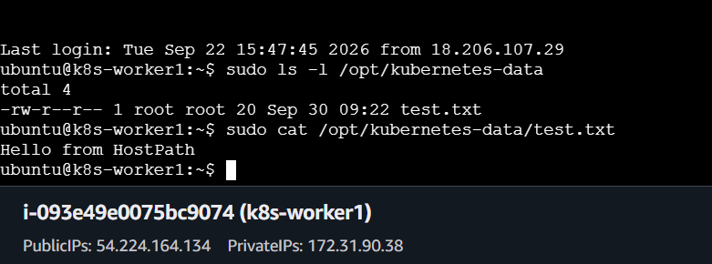

7. Delete the Pod
Return to the master and run:
kubectl delete pod hostpath-pod
Expected:
pod "hostpath-pod" deleted
Verify:
kubectl get pods
The hostpath-pod should no longer exist.

8. Recreate the Pod
kubectl apply -f hostpath-pod.yaml
Verify:
kubectl get pod hostpath-pod -o wide
Make sure it is again running on:
k8s-worker1
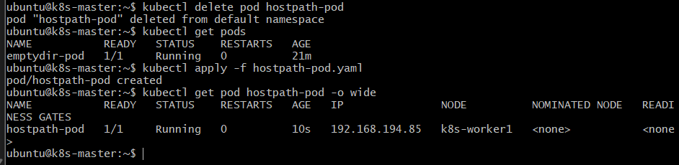

9. Validate Data Persistence
Read the file:
kubectl exec hostpath-pod -- cat /data/test.txt
Expected:
Hello from HostPath
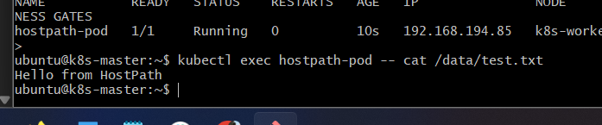

Outcome
- A hostPath volume was successfully configured.
- The Pod mounted /opt/kubernetes-data from k8s-worker1 to /data.
- Data written inside the container was stored on the worker node.
- After deleting and recreating the Pod, the data was still available.
- This demonstrates that HostPath data survives Pod deletion as long as the Pod is scheduled on the same node and the host directory remains intact.

Task 3: Deploy an Amazon EBS Volume Using Persistent Volume and Persistent Volume Claim (PVC)

Objective
To create an Amazon EBS volume, configure a Kubernetes PersistentVolume (PV) and PersistentVolumeClaim (PVC), attach the storage to a Pod, write data to it, and verify that the data persists after Pod recreation.
Important: This task requires an AWS EBS volume in the same AWS region/AZ as the Kubernetes worker node that will use it. EBS is block storage and normally supports attachment to one node at a time (ReadWriteOnce).

Implementation Steps

1. Identify the worker node and its Availability Zone
On the Kubernetes master:
kubectl get nodes -o wide
Then identify the AWS Availability Zone of k8s-worker1.
From AWS CLI:
aws ec2 describe-instances \
--filters "Name=private-ip-address,Values=<worker1-private-ip>" \
--query 'Reservations[].Instances[].Placement.AvailabilityZone' \
--output text
Example:
us-east-1a
Keep this AZ noted because the EBS volume must be created there.
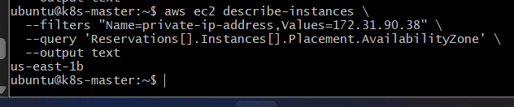

2. Create the EBS Volume
From a machine with AWS CLI configured:
aws ec2 create-volume \
--availability-zone us-east-1a \
--size 10 \
--volume-type gp3 \
--tag-specifications 'ResourceType=volume,Tags=[{Key=Name,Value=k8s-ebs-volume}]'
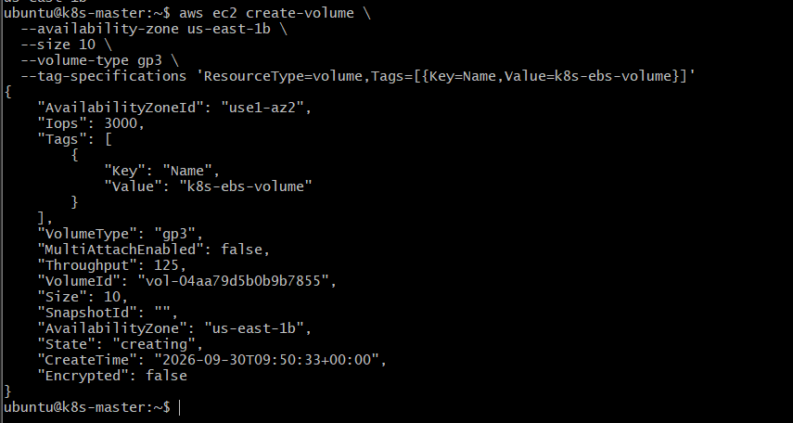
Verify:
aws ec2 describe-volumes \
--filters "Name=tag:Name,Values=k8s-ebs-volume" \
--query 'Volumes[*].[VolumeId,Size,State,AvailabilityZone]' \
--output table
You should get a volume ID similar to:
vol-0123456789abcdef
Save this Volume ID.
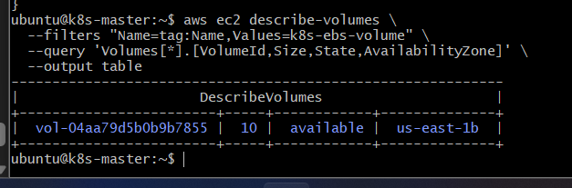

3. Create the PersistentVolume
On the Kubernetes master:
nano ebs-pv.yaml
Add:
apiVersion: v1
kind: PersistentVolume
metadata:
name: ebs-pv
spec:
capacity:
storage: 10Gi

volumeMode: Filesystem

accessModes:
- ReadWriteOnce

persistentVolumeReclaimPolicy: Retain

storageClassName: ebs-manual

awsElasticBlockStore:
volumeID: vol-0123456789abcdef
fsType: ext4
Replace:
vol-0123456789abcdef
with your actual EBS Volume ID.
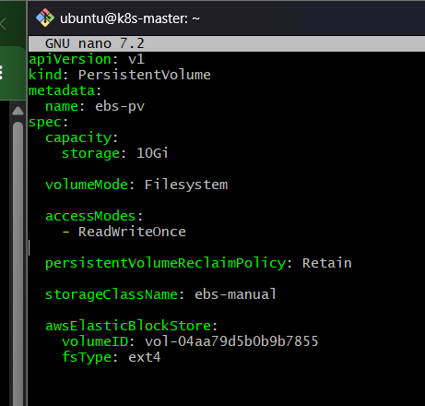
Apply:
kubectl apply -f ebs-pv.yaml
Verify:
kubectl get pv
Expected:
NAME CAPACITY ACCESS MODES RECLAIM POLICY STATUS STORAGECLASS
ebs-pv 10Gi RWO Retain Available ebs-manual
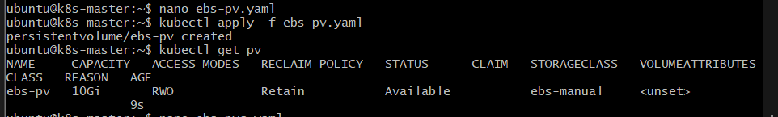

4. Create the PersistentVolumeClaim
nano ebs-pvc.yaml
Add:
apiVersion: v1
kind: PersistentVolumeClaim
metadata:
name: ebs-pvc
spec:
accessModes:
- ReadWriteOnce

resources:
requests:
storage: 10Gi

storageClassName: ebs-manual
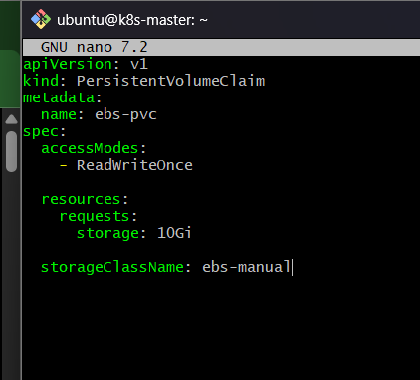
Apply:
kubectl apply -f ebs-pvc.yaml
Verify:
kubectl get pvc
Expected:
NAME STATUS VOLUME CAPACITY ACCESS MODES
ebs-pvc Bound ebs-pv 10Gi RWO
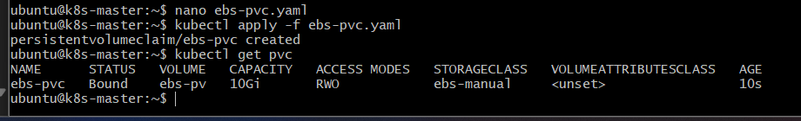
The relationship is:
Amazon EBS Volume
↓
PersistentVolume (PV)
↓
PersistentVolumeClaim (PVC)
↓
Pod
↓
Container
The Pod does not directly use the EBS volume. It uses the PVC, and the PVC is bound to the PV.

5. Create a Pod Using the PVC
nano ebs-pod.yaml
Add:
apiVersion: v1
kind: Pod
metadata:
name: ebs-pod
spec:
nodeSelector:
kubernetes.io/hostname: k8s-worker1

containers:
- name: nginx
image: nginx

volumeMounts:
- name: ebs-storage
mountPath: /data

volumes:
- name: ebs-storage
persistentVolumeClaim:
claimName: ebs-pvc
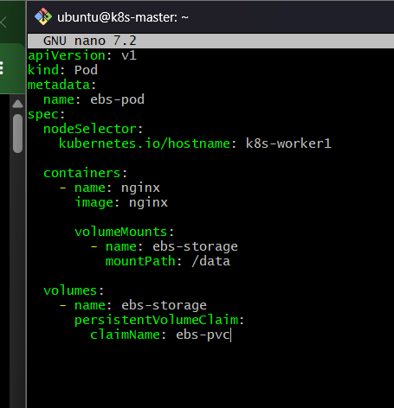
Apply:
kubectl apply -f ebs-pod.yaml
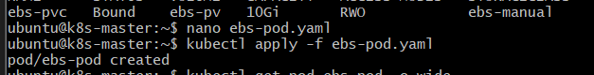

6. Verify the Pod
kubectl get pod ebs-pod -o wide
Expected:
NAME READY STATUS RESTARTS AGE
ebs-pod 1/1 Running 0 ...
Verify the PVC:
kubectl get pvc
Expected:
ebs-pvc Bound
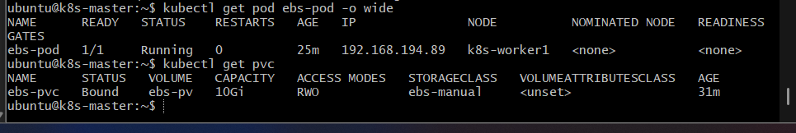

7. Write Data to the EBS Volume
kubectl exec ebs-pod -- sh -c 'echo "Hello from Amazon EBS" > /data/ebs-test.txt'
Verify:
kubectl exec ebs-pod -- cat /data/ebs-test.txt
Expected:
Hello from Amazon EBS

8. Delete the Pod
kubectl delete pod ebs-pod
Verify:
kubectl get pods

9. Recreate the Pod
kubectl apply -f ebs-pod.yaml
Wait until it is running:
kubectl get pod ebs-pod -o wide
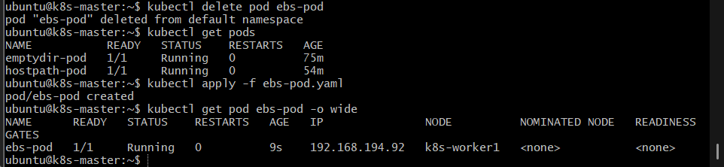

10. Validate EBS Data Persistence
kubectl exec ebs-pod -- cat /data/ebs-test.txt
Expected:
Hello from Amazon EBS
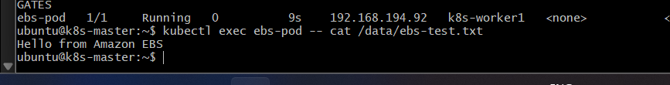
This confirms that the data survived Pod deletion and recreation because the data is stored on the EBS volume rather than inside the container filesystem.

Outcome
- An Amazon EBS gp3 volume was created.
- A Kubernetes PersistentVolume (PV) was configured for the EBS volume.
- A PersistentVolumeClaim (PVC) successfully bound to the PV.
- The Pod mounted the PVC at /data.
- Data was written to the EBS-backed storage.
- After deleting and recreating the Pod, the data remained available.

Task 4: Set Up an Amazon EFS Volume and Attach It to Multiple Pods

Objective
To configure Amazon EFS as shared Kubernetes storage, create a PersistentVolume (PV) and PersistentVolumeClaim (PVC), mount the same EFS storage into multiple Pods, and verify that data written by one Pod can be accessed by another Pod.
Key difference from Task 3: EBS is normally attached to one node at a time, while EFS is shared network storage and can be mounted by multiple Pods across different worker nodes.

Implementation Steps

1. Create an Amazon EFS File System
From AWS CLI:
aws efs create-file-system \
--creation-token k8s-efs-lab \
--performance-mode generalPurpose \
--throughput-mode bursting \
--tags Key=Name,Value=k8s-efs
The output contains:
FileSystemId: fs-xxxxxxxxxxxxxxxxx
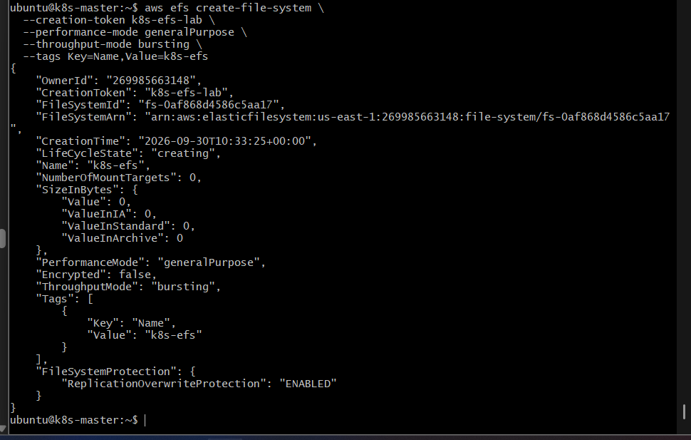
Save the FileSystem ID.
Verify:
aws efs describe-file-systems \
--query 'FileSystems[*].[FileSystemId,LifeCycleState,SizeInBytes.Value]' \
--output table
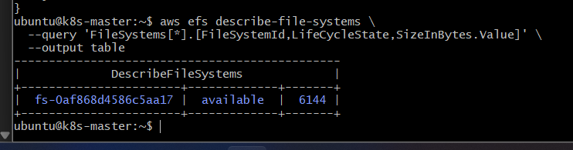

2. Create EFS Mount Targets
EFS needs a mount target in the VPC/subnet where your Kubernetes worker nodes are running.
First identify the VPC:
kubectl get nodes -o wide
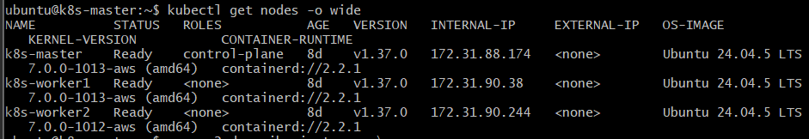
Then create an EFS mount target in the worker-node subnet.
Example:
aws efs create-mount-target \
--file-system-id fs-xxxxxxxxxxxxxxxxx \
--subnet-id subnet-xxxxxxxxxxxxxxxxx \
--security-groups sg-xxxxxxxxxxxxxxxxx
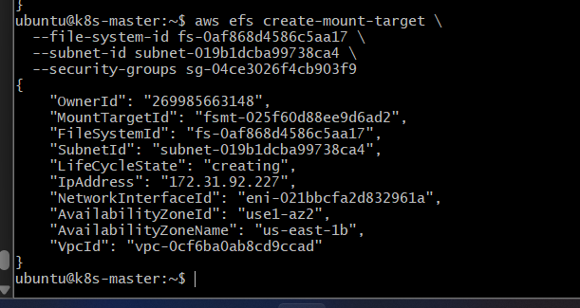

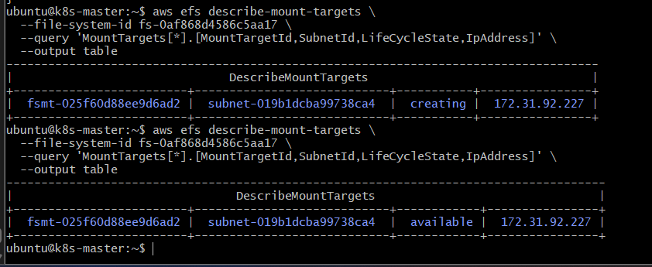
Repeat this for another worker-node subnet if you want EFS available across multiple Availability Zones.
Important: The EFS security group must allow NFS TCP port 2049 from the security group used by your Kubernetes worker nodes.
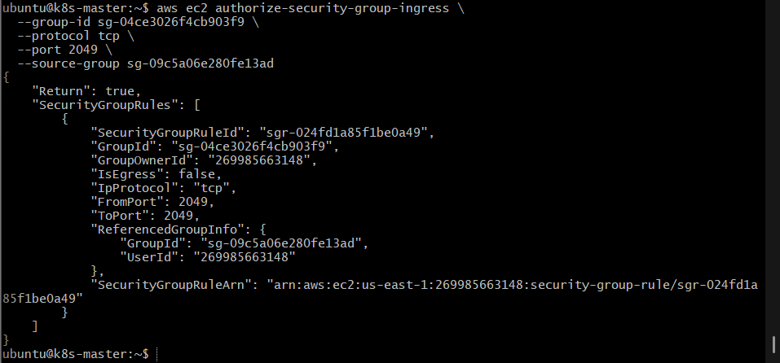

3. Create the PersistentVolume
On the Kubernetes master:
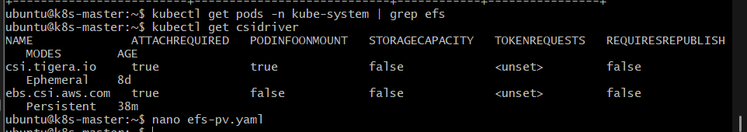
nano efs-pv.yaml
Add:
apiVersion: v1
kind: PersistentVolume
metadata:
name: efs-pv
spec:
capacity:
storage: 5Gi

volumeMode: Filesystem

accessModes:
- ReadWriteMany

persistentVolumeReclaimPolicy: Retain

storageClassName: efs-manual

csi:
driver: efs.csi.aws.com
volumeHandle: fs-xxxxxxxxxxxxxxxxx
Replace:
fs-xxxxxxxxxxxxxxxxx
with your actual EFS File System ID.
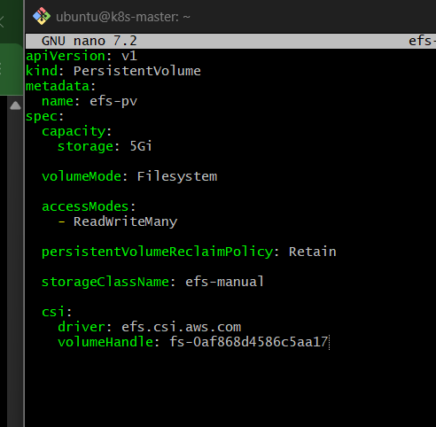
Apply:
kubectl apply -f efs-pv.yaml
Verify:
kubectl get pv
Expected:
NAME CAPACITY ACCESS MODES RECLAIM POLICY STATUS STORAGECLASS
efs-pv 5Gi RWX Retain Available efs-manual
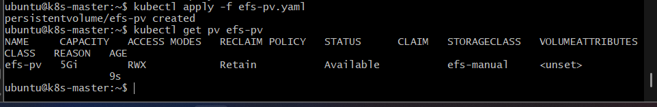

4. Create the PersistentVolumeClaim
nano efs-pvc.yaml
Add:
apiVersion: v1
kind: PersistentVolumeClaim
metadata:
name: efs-pvc
spec:
accessModes:
- ReadWriteMany

resources:
requests:
storage: 5Gi

storageClassName: efs-manual
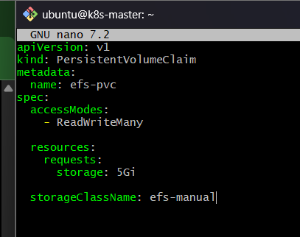
Apply:
kubectl apply -f efs-pvc.yaml
Verify:
kubectl get pvc
Expected:
NAME STATUS VOLUME CAPACITY ACCESS MODES
efs-pvc Bound efs-pv 5Gi RWX
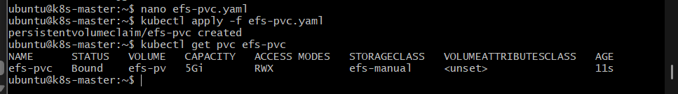

5. Create the First Pod
nano efs-pod-1.yaml
Add:
apiVersion: v1
kind: Pod
metadata:
name: efs-pod-1
spec:
containers:
- name: nginx
image: nginx

volumeMounts:
- name: efs-storage
mountPath: /data

volumes:
- name: efs-storage
persistentVolumeClaim:
claimName: efs-pvc
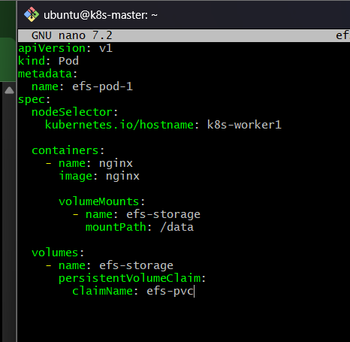
Apply:
kubectl apply -f efs-pod-1.yaml

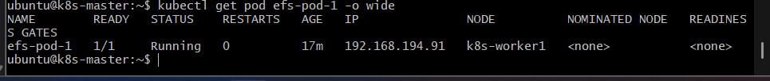

6. Create the Second Pod
nano efs-pod-2.yaml
Add:
apiVersion: v1
kind: Pod
metadata:
name: efs-pod-2
spec:
containers:
- name: nginx
image: nginx

volumeMounts:
- name: efs-storage
mountPath: /data

volumes:
- name: efs-storage
persistentVolumeClaim:
claimName: efs-pvc
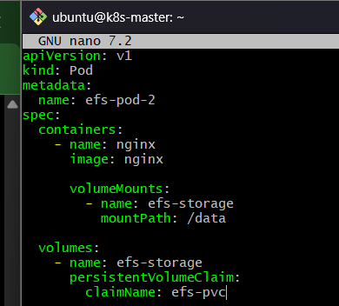
Apply:
kubectl apply -f efs-pod-2.yaml
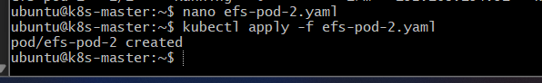

7. Verify Both Pods
kubectl get pods -o wide
Expected:
NAME READY STATUS IP NODE
efs-pod-1 1/1 Running 192.168.x.x k8s-worker1
efs-pod-2 1/1 Running 192.168.x.x k8s-worker2

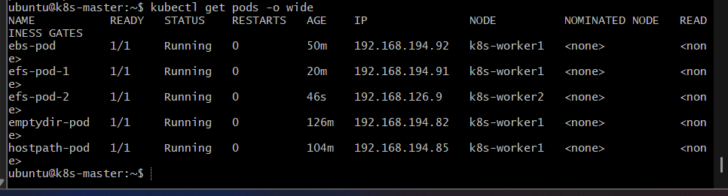
The important point is that the Pods can run on different worker nodes while using the same EFS storage.

8. Write Data from Pod 1
kubectl exec efs-pod-1 -- sh -c 'echo "Hello from EFS Pod 1" > /data/shared.txt'
Verify:
kubectl exec efs-pod-1 -- cat /data/shared.txt
Expected:
Hello from EFS Pod 1

9. Read the Same Data from Pod 2
kubectl exec efs-pod-2 -- cat /data/shared.txt
Expected:
Hello from EFS Pod 1
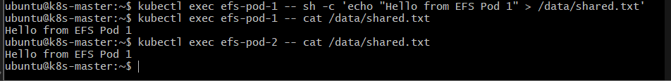
This is the key validation for this task.
Pod 1 wrote the file:
efs-pod-1
↓
EFS
↓
shared.txt
Pod 2 then read the same file:
EFS
↓
shared.txt
↓
efs-pod-2

Outcome
- Amazon EFS was successfully configured as shared storage.
- Kubernetes PV and PVC were created using the EFS CSI driver.
- The PVC used ReadWriteMany (RWX).
- Two Pods mounted the same PVC.
- Pod 1 successfully created data on EFS.
- Pod 2 successfully accessed the same data.
- The shared-storage architecture is:
Amazon EFS
│
┌───────┴───────┐
│ │
PV/PVC PV/PVC
│ │
efs-pod-1 efs-pod-2
│ │
/data /data
└───────┬───────┘
│
Same shared data

Task 5: Implement and Test Liveness and Readiness Probes in a Kubernetes Pod

Objective
To configure liveness and readiness probes in a Kubernetes Pod and verify how Kubernetes detects an unhealthy container and controls whether the Pod receives traffic.
- Liveness Probe → determines whether the container is alive. If it repeatedly fails, Kubernetes restarts the container.
- Readiness Probe → determines whether the application is ready to receive traffic. If it fails, the Pod is removed from the Service's endpoints, but the container is not necessarily restarted.

Implementation Steps

1. Create the Pod YAML
nano probes-pod.yaml
Add:
apiVersion: v1
kind: Pod
metadata:
name: probes-pod
labels:
app: probes-demo

spec:
containers:
- name: nginx
image: nginx

ports:
- containerPort: 80

livenessProbe:
httpGet:
path: /
port: 80
initialDelaySeconds: 10
periodSeconds: 5
timeoutSeconds: 2
failureThreshold: 3

readinessProbe:
httpGet:
path: /
port: 80
initialDelaySeconds: 5
periodSeconds: 5
timeoutSeconds: 2
failureThreshold: 3

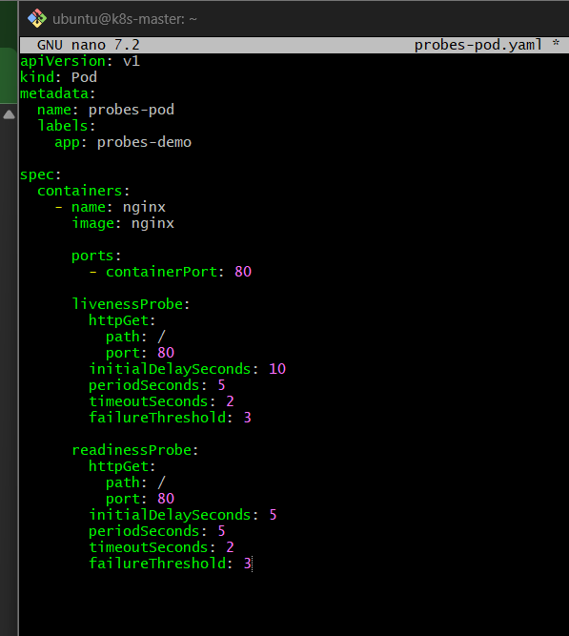
Save and exit.

2. Create the Pod
kubectl apply -f probes-pod.yaml
Expected:
pod/probes-pod created

3. Check the Pod Status
kubectl get pod probes-pod
Expected:
NAME READY STATUS RESTARTS AGE
probes-pod 1/1 Running 0 ...
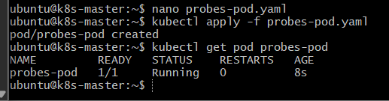
READY 1/1 means the readiness probe is currently successful.

4. Check the Probe Configuration
kubectl describe pod probes-pod
Look for:
Liveness: http-get http://:80/ delay=10s timeout=2s period=5s
Readiness: http-get http://:80/ delay=5s timeout=2s period=5s
You can also check Events:
kubectl describe pod probes-pod | tail -20
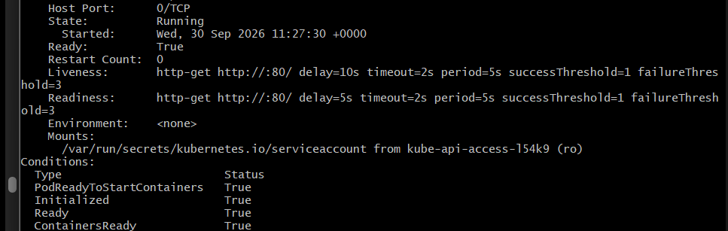

5. Create a Service
To demonstrate the purpose of the readiness probe, create a Service.
nano probes-service.yaml
Add:
apiVersion: v1
kind: Service
metadata:
name: probes-service
spec:
selector:
app: probes-demo

ports:
- port: 80
targetPort: 80

type: ClusterIP

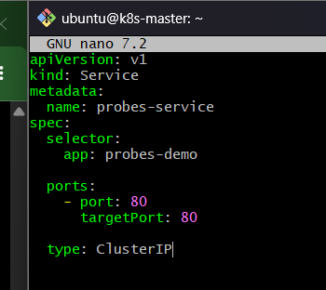
Apply:
kubectl apply -f probes-service.yaml

6. Verify the Service Endpoint
kubectl get endpoints probes-service
You should see the Pod IP:
NAME ENDPOINTS
probes-service 192.168.x.x:80
This means the Pod is Ready and is available through the Service.
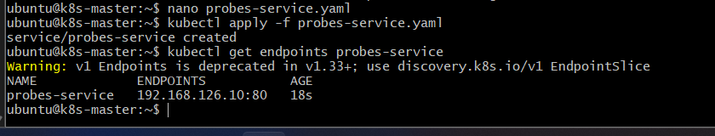

7. Test the Readiness Probe
Temporarily make the Nginx application fail the readiness check.
Change the readiness probe path:
kubectl edit pod probes-pod
Change:
path: /
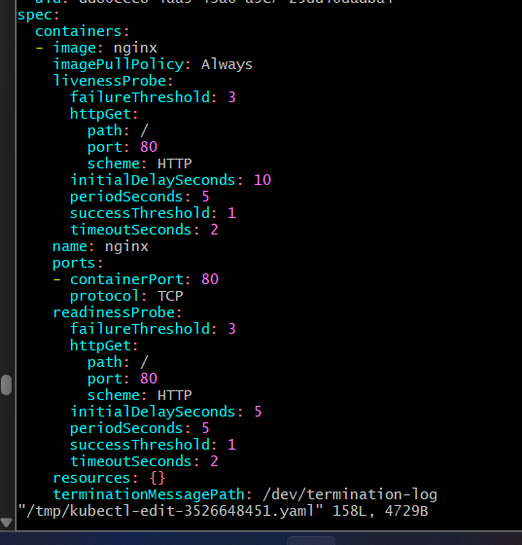
to:
path: /wrong
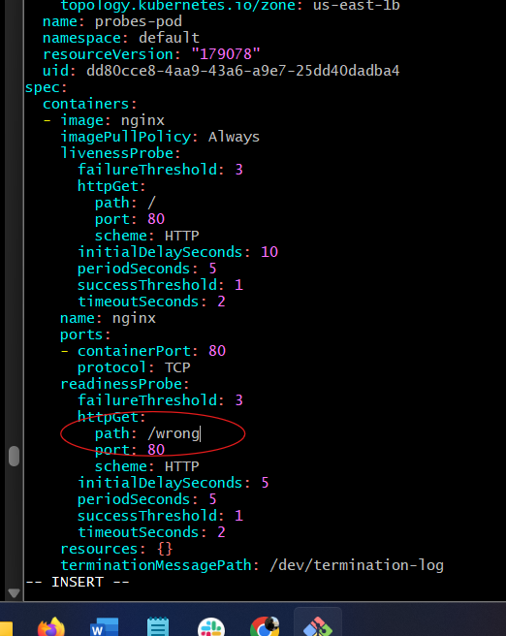
The readiness probe will now receive an HTTP 404 response.
Check:
kubectl get pod probes-pod
You should eventually see:
NAME READY STATUS RESTARTS
probes-pod 0/1 Running 0
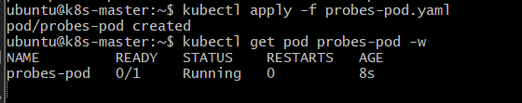
Important: Notice that the Pod is still Running, but READY changed from 1/1 to 0/1.
Now check the Service:
kubectl get endpoints probes-service
The endpoint should be removed:
NAME ENDPOINTS
probes-service <none>
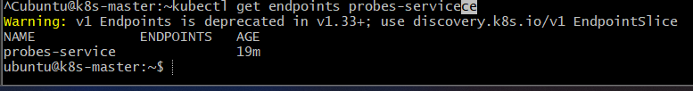
This demonstrates the purpose of the readiness probe:
Readiness fails
↓
Pod remains Running
↓
Pod becomes NotReady
↓
Service removes Pod from endpoints
↓
No new traffic is sent to the Pod

8. Restore the Readiness Probe
Edit the Pod again:
kubectl edit pod probes-pod
Change:
path: /wrong
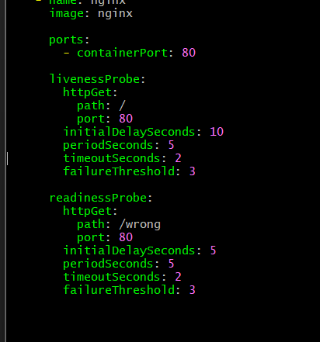
back to:
path: /
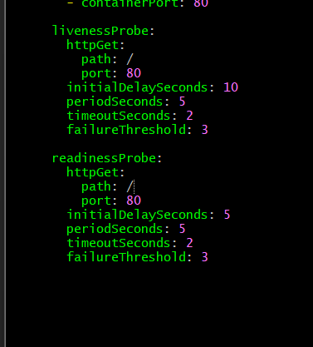
Verify:
kubectl get pod probes-pod
Expected:
NAME READY STATUS
probes-pod 1/1 Running
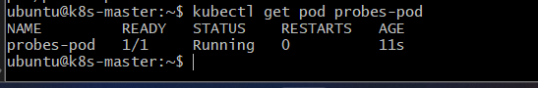
Then:
kubectl get endpoints probes-service
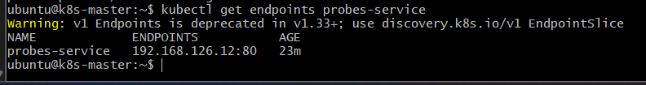
The Pod IP should appear again.

9. Test the Liveness Probe
For the liveness test, we will make the liveness endpoint fail.
Edit the Pod:
kubectl edit pod probes-pod
Change only the liveness path:
livenessProbe:
httpGet:
path: /wrong
port: 80
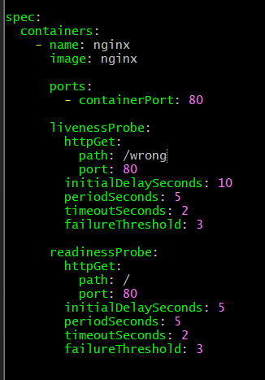
Keep the readiness probe as:
readinessProbe:
httpGet:
path: /
port: 80
After the configured failures, Kubernetes will restart the container.
Check:
kubectl get pod probes-pod
You should eventually see the restart count increase:
NAME READY STATUS RESTARTS
probes-pod 1/1 Running 1
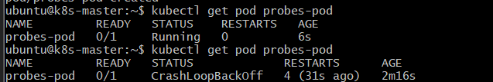
The exact timing depends on the probe configuration.
Check:
kubectl describe pod probes-pod
Look at the Events section for liveness-probe failures and container restart activity.
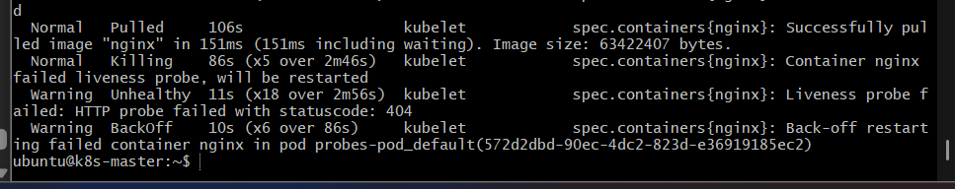

10. Restore the Liveness Probe
Change:
path: /wrong
back to:
path: /
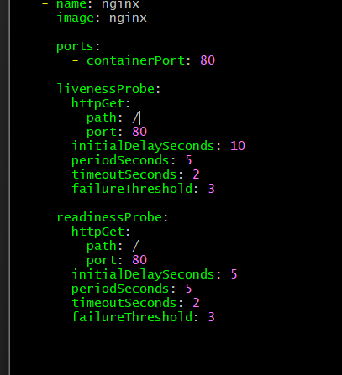

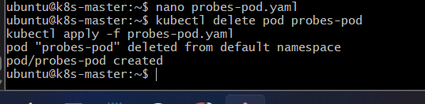
Then verify:
kubectl get pod probes-pod
Expected:
NAME READY STATUS RESTARTS
probes-pod 1/1 Running 1

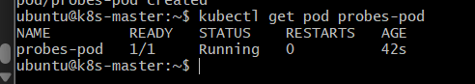
The restart count may remain 1 because Kubernetes does not reset the historical restart count.

Outcome
- A Pod was configured with both liveness and readiness probes.
- The readiness probe determined whether the Pod should receive Service traffic.
- When readiness failed:
  - Pod remained running.
  - Pod became 0/1 Ready.
  - Service removed the Pod from its endpoints.
- When liveness failed repeatedly:
  - Kubernetes restarted the container.
- The difference can be remembered as:
Liveness Probe
↓
"Is the application alive?"
↓
FAIL
↓
Container restart

Readiness Probe
↓
"Can the application receive traffic?"
↓
FAIL
↓
Pod marked NotReady
↓
Removed from Service endpoints

